**Alexandre Santiago da Silva**

**ID: 100285742**

# **Library API using Amazon Web Services**

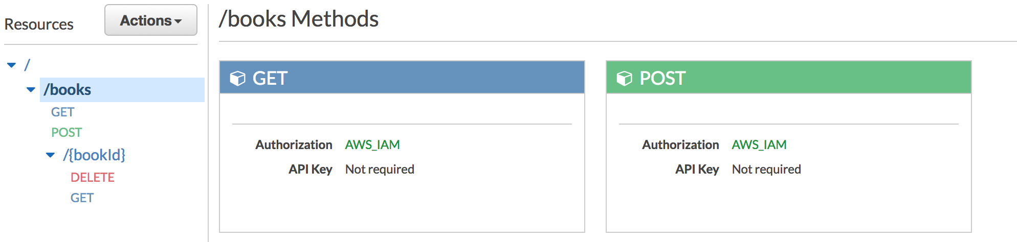

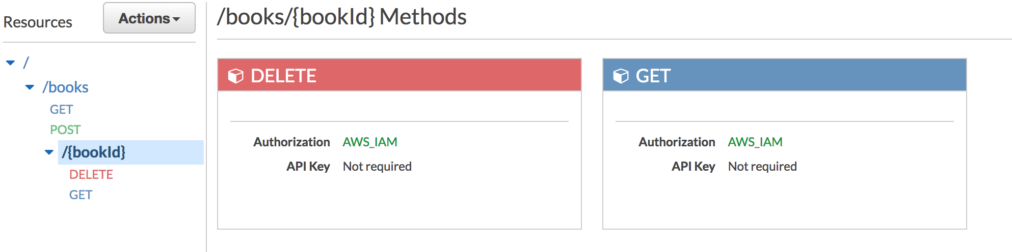

## **Sample json**

{

"item" : "book",

"bookid" : "20171030003",

"author" : "Ecco, Humberto",

"genre" : "Fiction",

"title" : "Name of the Rose, The"

}

,

{

"item" : "book",

"bookid" : "20171030004",

"author" : "Doyle, Arthur Conan",

"genre" : "Fiction",

"title" : "Study in Scarlet, A"

}

**Methods**

**GET**

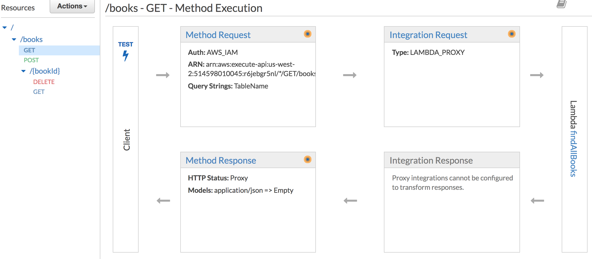

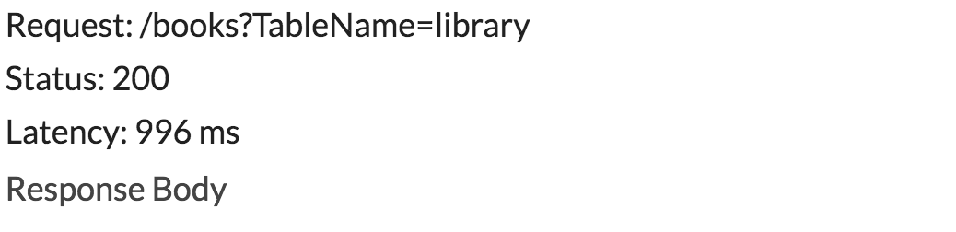

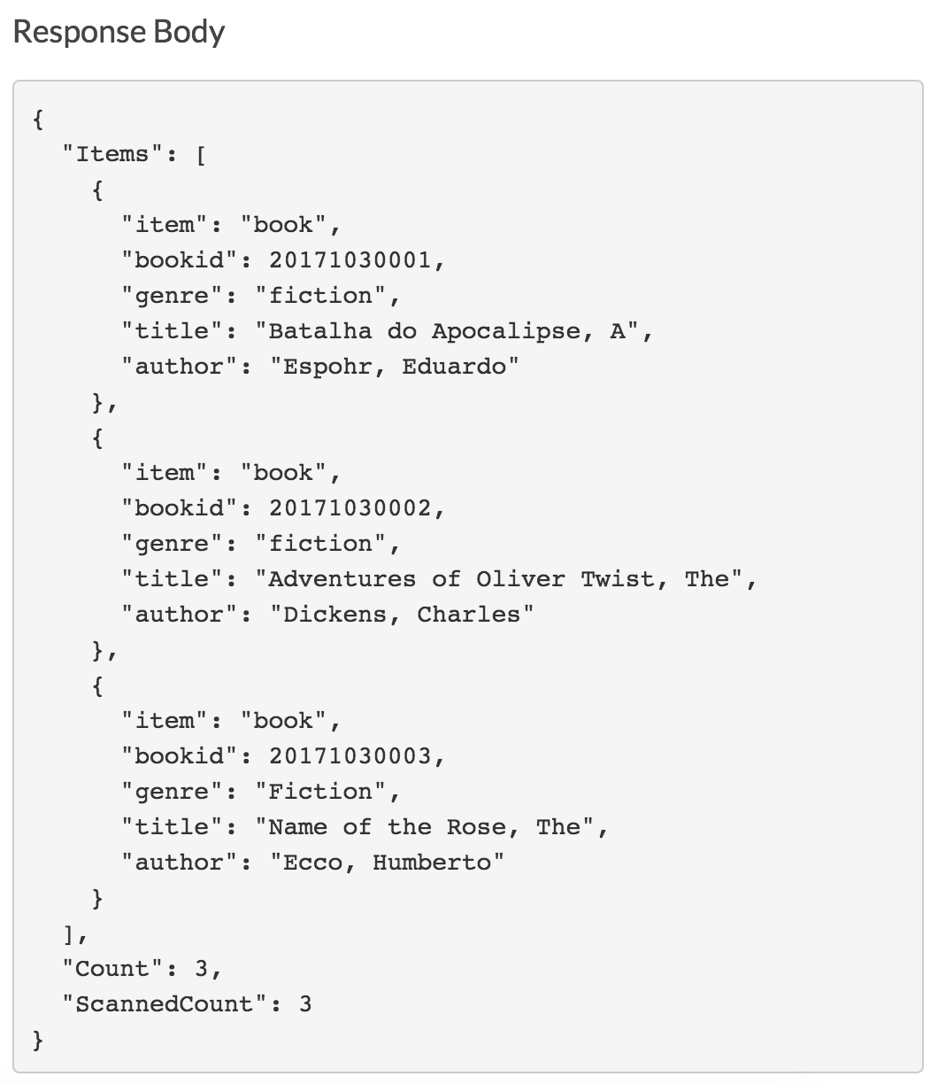

**POST**

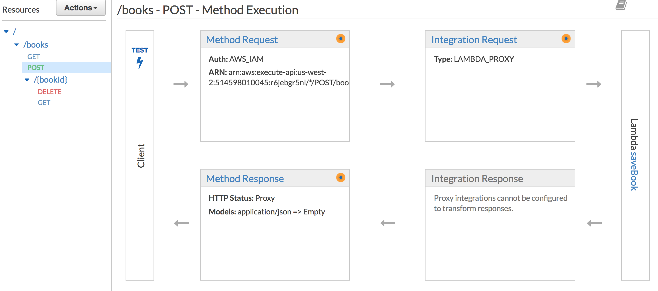

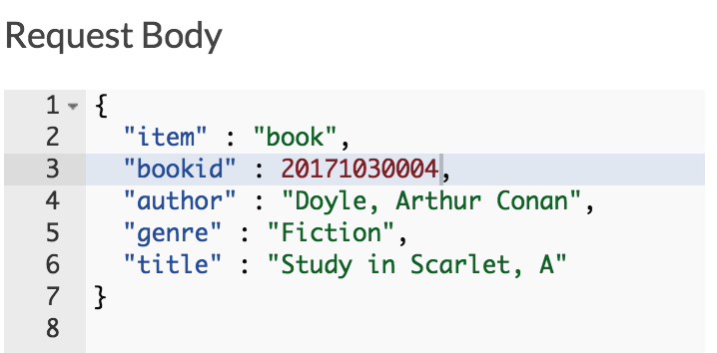

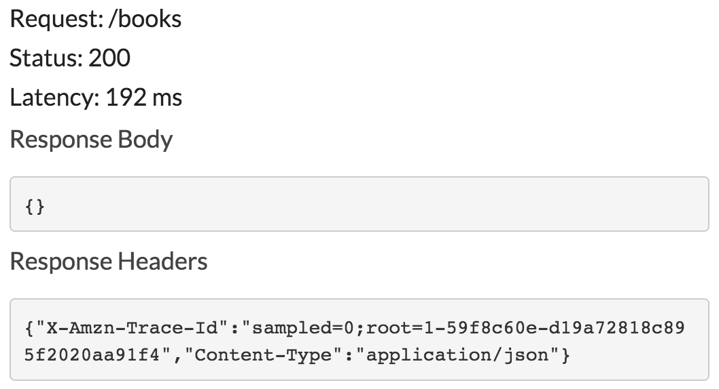

**DELETE**

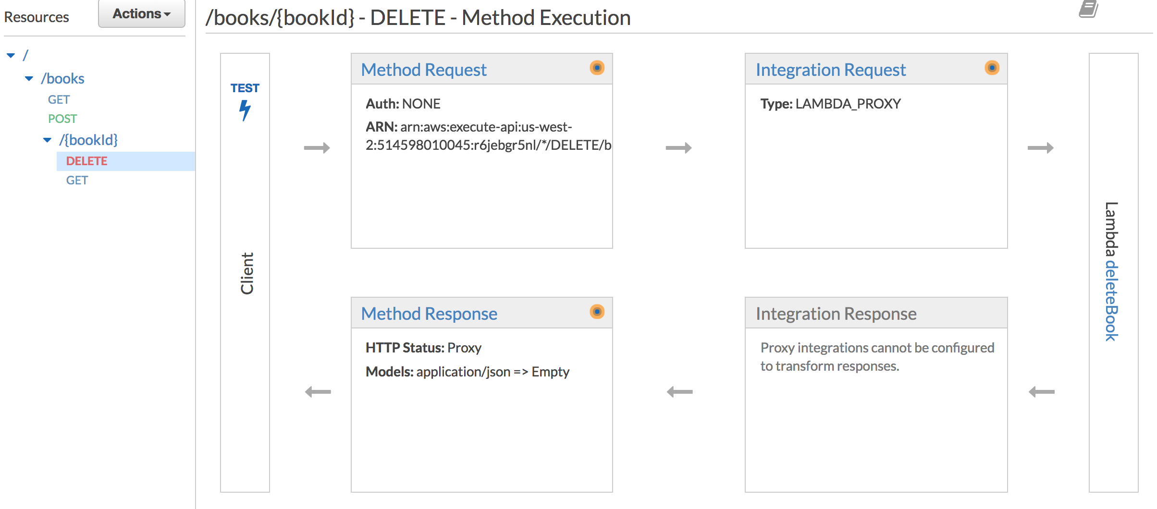

**GET**

